June 21, 2010

Monmouth Road JAZZED by Belgraves - Big Tony's
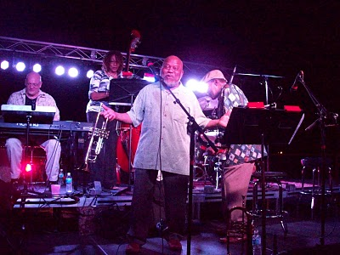
Marcus Belgrave at Big Tony's First Annual Jazz Festival. Perfect!
Monmouth roadies had back stage passes...Make that: Monmouth Road was THE backstage to Big Tony's first annual Jazz Festival. What a treat, what a perfect venue! A whole weekend of top notch jazz performances by local and international musicians culminating with the headline act from non other than internationally renownd horn man, Marcus Belgrave. But wait...That's not all! Also sharing that stage was the sexy, soulful and powerful Joan Bow-Belgrave whos voice carried up tree-lined Monmouth with the sweet clarity and perfection that is her. Incredible!
How Did this Come to Be?
Would you believe with a phone call? Tony from name sake restaurant "Big Tony's" decided to take a shot at making a phone call to Marcus Belgrave's home. After a couple of rings a voice answered "Hello". Tony asked if Mr. Belgrave was available and the voice replied: "You got him" and that was that. Mr. Belgrave brought Tony's jazz festival out of the dream phase and gave Big Tony the horsepower needed to make it an annual event. After that it was Tony's turn to put wings on this thing. He quickly had posters made up, worked out the logistics with the city and with the neighbourhood (what another party?) and as the story goes...
The weekend's line-up looked like this:
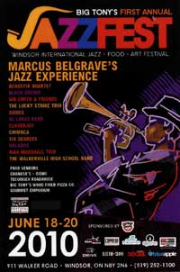

Big Tony’s JazzFest Music Lineup

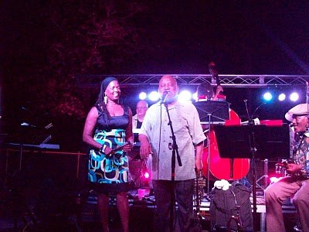
Joan Bow-Belgrave along with Marcus Belgrave. What a treat!

