July 10, 2012 at 10:22 am
Recording project wants Detroiters to share tales
- By Josh Katzenstein
- The Detroit News
- 1 Comments
- CORRECTION
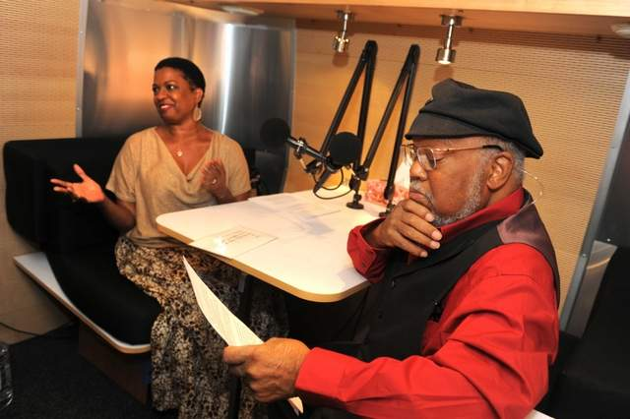
Purchase Image
Detroit jazz legend Marcus Belgrave prepares Monday for an interview by wife Joan about the city’s musical history and why he moved there in the 1960s. The session was part of StoryCorps’ effort to share and preserve people’s stories. (Max Ortiz / The Detroit News)
Detroit— Jazz great Marcus Belgrave doesn't know why so many people are curious about Detroit, but he said people ask about the city wherever he travels.
With the questions coming from his wife, Joan, Belgrave recorded an interview Monday about the city's musical history, why he moved to Detroit in the 1960s and other topics for StoryCorps, a nonprofit aimed at sharing and preserving people's stories across the United States.
And while most Detroiters haven't toured with Ray Charles or played with the likes of Ella Fitzgerald and Sammy Davis Jr., StoryCorps is giving everyone in the city a chance to share their story.
The project will have its mobile recording studio parked outside the Carr Center downtown across from Harmonie Park for the next month, and people from all walks of life can share their story and have it preserved in the American Folklife Center at the Library of Congress.
The recordings will be played locally on WDET-101.9 FM and some will be rebroadcast on National Public Radio.
"Think of all the kinds of levels of work and interest (in Detroit). That's one of the things that's so fascinating," said Wayne State University President Allan Gilmour, a former chief financial officer at Ford Motor Co. who was interviewed Monday by his chief of staff, Michael Wright.
The two said they discussed Gilmour's decision to come out of retirement twice, the auto company and his public announcement of being gay.
StoryCorps last came to Detroit in 2007 and has now been to every state, site supervisor Virginia Lora said. People can interview or be interviewed by a friend, relative, colleague or anyone they want in the cozy studio.
"Because of the great history of the city, we realized there are still so many stories that can be told," Lora said.
"Coming back to a city once is hardly enough especially as time goes along and things change and communities change."
After a four-week stay in Detroit through Aug. 7, the recording studio will move to the Islamic Center of America in Dearborn from Aug. 9-11 during Ramadan, the Islamic month of fasting.
Before recording his interview, Belgrave said he planned to explain why he moved from Chester, Pa., to Detroit in the 1960s instead of other hot music cities.
"All those five years that I traveled with (Ray Charles), I was looking for a place to stay, and of all the big major cities, Detroit held the best candle," Belgrave said. His interview — and explanation — will air on WDET next week.
jkatzenstein@detnews.com

From The Detroit News: http://www.detroitnews.com/article/20120710/METRO01/207100345#ixzz20bluSXty

